30.79: a) 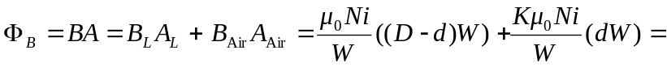
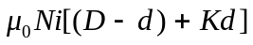
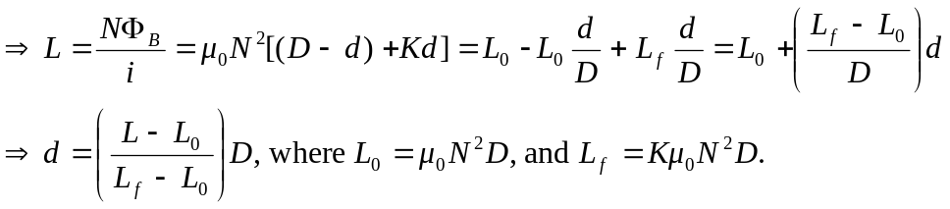
b) Using 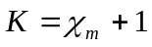 we can find the inductance for any height 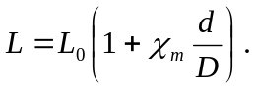
__________________________________________________________________

Height of Fluid Inductance of Liquid Oxygen Inductance of Mercury
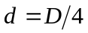 0.63024 H 0.63000 H
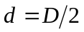 0.63048 H 0.62999 H
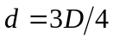 0.63072 H 0.62999 H
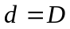 0.63096 H 0.62998 H
__________________________________________________________________
Where are used the values
d) The volume gauge is much better for the liquid oxygen than the mercury because there is an easily detectable spread of values for the liquid oxygen, but not for the mercury.

